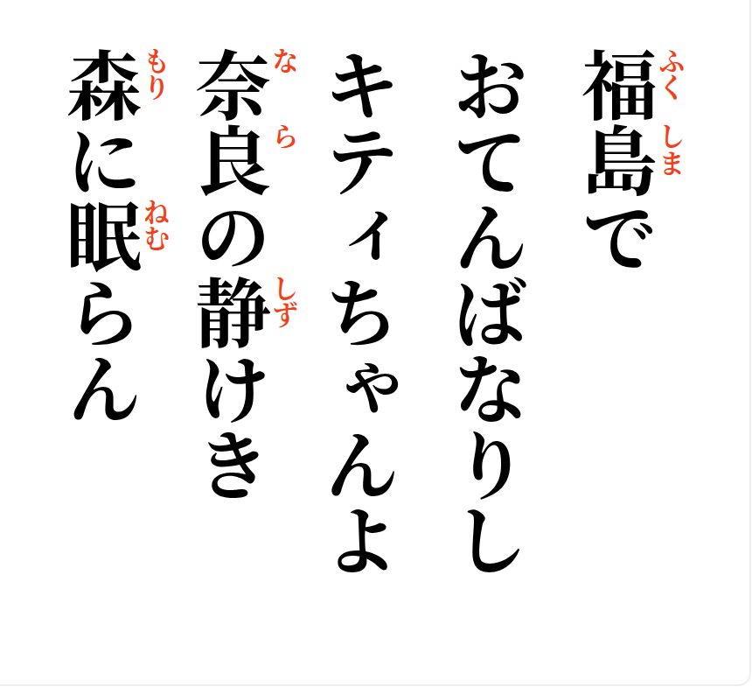
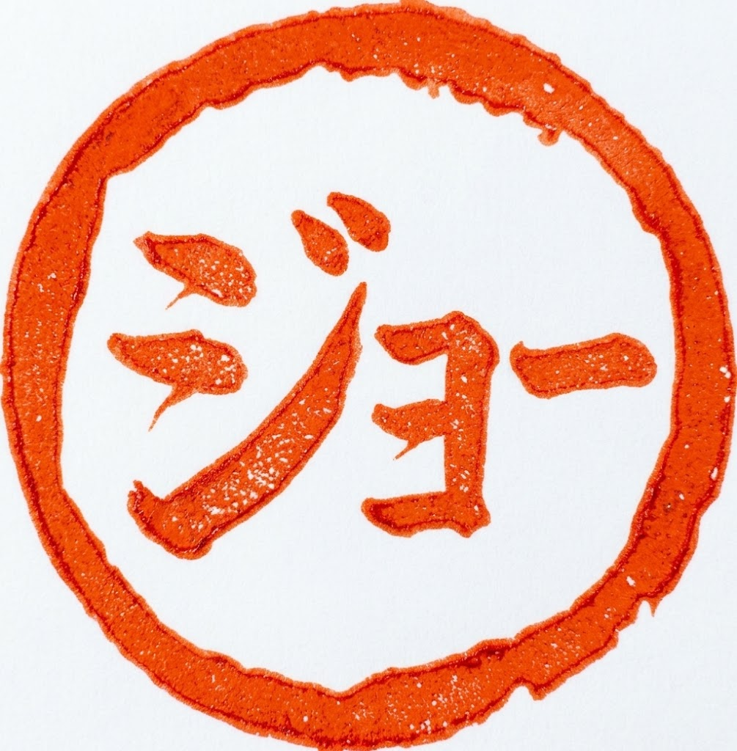
2026-10-04
In Fukushima,
once a little tomboy—
Kitty-chan,
may you sleep now in the
quiet forests of Nara.

